К | 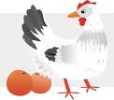 | 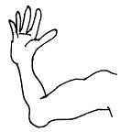 | 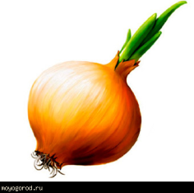
______________

_______ _______

________________

_____

_____ _____

_____ _____ _____

П |  |  | 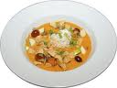
______________

_______ _______

________________

_____

_____ _____

_____ _____ _____

Т | 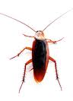 | 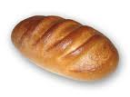 | 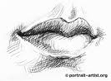
______________

_______ _______

________________

_____

_____ _____

_____ _____ _____

Н | 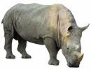 | 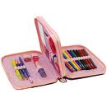 | 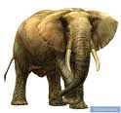
______________

_______ _______

________________

_____

_____ _____

_____ _____ _____

М | 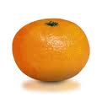 | 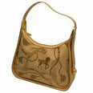 | 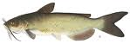
______________

_______ _______

________________

_____

_____ _____

_____ _____ _____

Б | 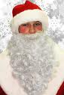 | 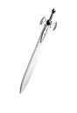 | 
______________

_______ _______

________________

_____

_____ _____

_____ _____ _____

Г | 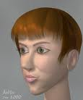 | 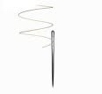 | 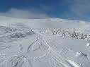
______________

_______ _______

________________

_____

_____ _____

_____ _____ _____

Д |  | 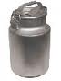 | 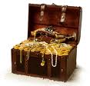
______________

_______ _______

________________

_____

_____ _____

_____ _____ _____

В | 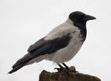 | 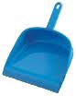 | 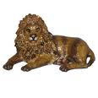
______________

_______ _______

________________

_____

_____ _____

_____ _____ _____

Ф | 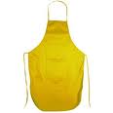 | 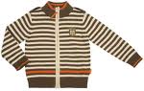 | 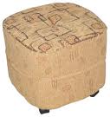
______________

_______ _______

________________

_____

_____ _____

_____ _____ _____

Л | 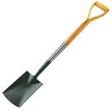 |  | 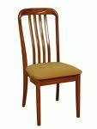
______________

_______ _______

________________

_____

_____ _____

_____ _____ _____

Р |  | 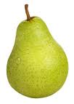 | 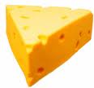
______________

_______ _______

________________

_____

_____ _____

_____ _____ _____

С | 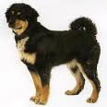 | 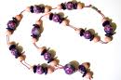 | 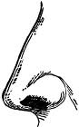
______________

_______ _______

________________

_____

_____ _____

_____ _____ _____

З | 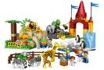 | 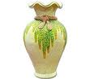 | 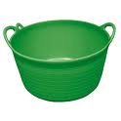
______________

_______ _______

________________

_____

_____ _____

_____ _____ _____

Х | 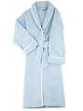 | 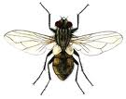 | 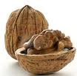
______________

_______ _______

________________

_____

_____ _____

_____ _____ _____

Ш | 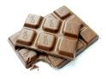 | 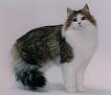 | 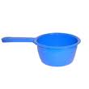
______________

_______ _______

________________

_____

_____ _____

_____ _____ _____

Ж | 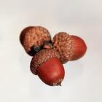 | 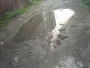 | 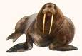
______________

_______ _______

________________

_____

_____ _____

_____ _____ _____

Ц | 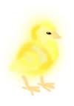 | 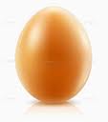 | 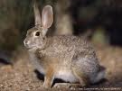
______________

_______ _______

________________

_____

_____ _____

_____ _____ _____

Ч | 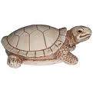 | 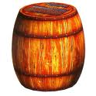 | 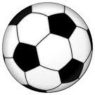
______________

_______ _______

________________

_____

_____ _____

_____ _____ _____

Щ | 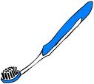 | 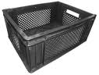 | 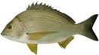
______________

_______ _______

________________

_____

_____ _____

_____ _____ _____

А | 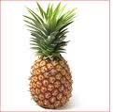 | 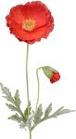 | 
______________

_______ _______

________________

_____

_____ _____

_____ _____ _____

У | 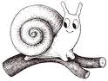 | 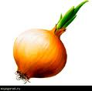 | АУ!
______________

_______ _______

________________

_____

_____ _____

_____ _____ _____

